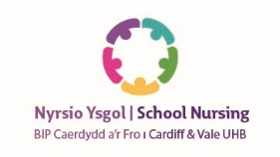
School Nyrsio

Nursing Ysgol


About Us
School Nursing teams are made up of multi-skilled staff including Support Workers, Community Staff Nurses (both work predominantly in Primary Schools) and qualified Specialist Community Public Health Nurses (working with High Schools). They all strive to work with pupils, families, and schools to improve health and wellbeing outcomes.

School Nursing teams are based in the community, there are three bases within Cardiff and the Vale. They are often the first point of contact when families or young people need advice and support about physical and/or emotional health issues. Their role is to provide evidence - based health information, promote/ advise re healthy lifestyles and to enable the child/young person manage existing health concerns. In this way they are able to benefit fully from their educational opportunities and are empowered to reach their full potential.
The Cardiff and Vale School Nursing Service is delivered via a rights-based approach in-line with the UNCRC (1989). We also offer support and guidance to help build resilience and to advocate for those more vulnerable due to safeguarding concerns or additional needs.

What do School Nurses do?...

Physical health

We provide up to date information/advice to families, children and young people and signpost or refer to other specialist services.

The service aim going forward is to provide health education/ promotion sessions on a range of topics- healthy/fussy eating advice /puberty/sexual health/toileting continence issues/ behaviour issues/emotional health issues. This will be resource dependant.

Delivery of the National Screening, Surveillance and Immunisation Programmes in the school setting
We deliver a School Entry Health Review for reception aged children which includes height, weight and vision screening. Data gathered contributes to the Welsh Government CMP (Child measurement programme). www.publichealthwales.org/childmeasurement (for more information)
The purpose of the Health Review is to assess the child’s health needs on starting school, promotion of health and wellbeing ensuring that children are school ready. Contact information for the school nursing teams is provided for parents/ carers.

Promotion of Emotional Wellbeing and Supporting the Mental Health Needs of School Age Children
The role of the School Nurse is pivotal in supporting the emotional wellbeing of children and young people. We provide weekly Young Person’s Health Hubs in the high school settings. This provides a confidential opportunity for young people to seek advice for their physical and/or emotional health concerns. Alternatively, they can contact the service via CHAT Health.
The service benefits from two specialist Nurses who are trained in the management of Emotional wellbeing. They also deliver training to support the School Nurses and provide more individual support for vulnerable young people attending Pupil Referral Units and those being Electively Home Educated.
Pupils attending the Health Hubs are able to access a wide range of support on topics including, eating disorders, sexual health and C-Card, Gender identity and safeguarding.

Chat health

Young people aged 11-19 can access the School Nursing service via text for confidential, anonymous health advice and support. Mon- Fri 8:30-16:30 except bank holidays
Text:07520615718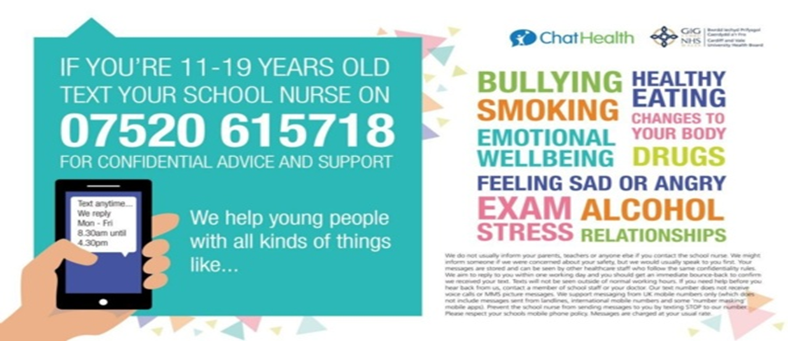

PARENTLINE- text in service for parents of 5-11 year olds

This is a new service launching on April 18th 2023.

Parents will be able to access a school nurse for advice and support with a wide range of health problems. This isn’t a diagnostic service but we can provide information, eg, re emotional well- being, healthy eating, continence issues.

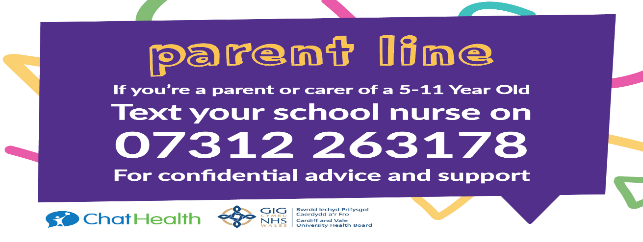

The School Nursing Service assists the School- based Immunisation team providing seasonal influenza and HPV vaccinations
Influenza: All children of school age are eligible and should have an influenza vaccination every year. The School nursing service has been offering the vaccination for some years now as part of the national flu programme. The benefits of this are that they and the general population stay well and they are able to attend school.
HPV: The HPV vaccine is offered to all girls and boys in school year 8/9 (currently 2 doses). The HPV vaccination helps protect young people from being infected by the Human Papillomavirus (HPV). From September 2023 only 1 dose of HPV will be offered due to updated evidence-based guidance.
This virus increases the risk of developing some cancers later in life, such as cervical cancer, some mouth and throat cancers, and some cancers of the anus and genital areas. The HPV vaccine does not protect against other sexually transmitted diseases. For more information contact your School Nurse.
Contact us- If you don’t feel you know your School nurse please ring and arrange to meet up with them to discuss how we can help the school community.
Vale School Nursing Team: (Barry Hospital)
01446 704114
Cardiff West School Nursing Team: (Western Services. Grand Avenue. Ely)
02921832204
Cardiff East School Nursing Team: (Llanederyn Wellbeing Hub)
02921833114
Senior Nurse for School Nursing: Sandra Dredge
Operational Managers: Andrea Cooper, Cath Cawte. Carol Rogers ( Updated April 23

