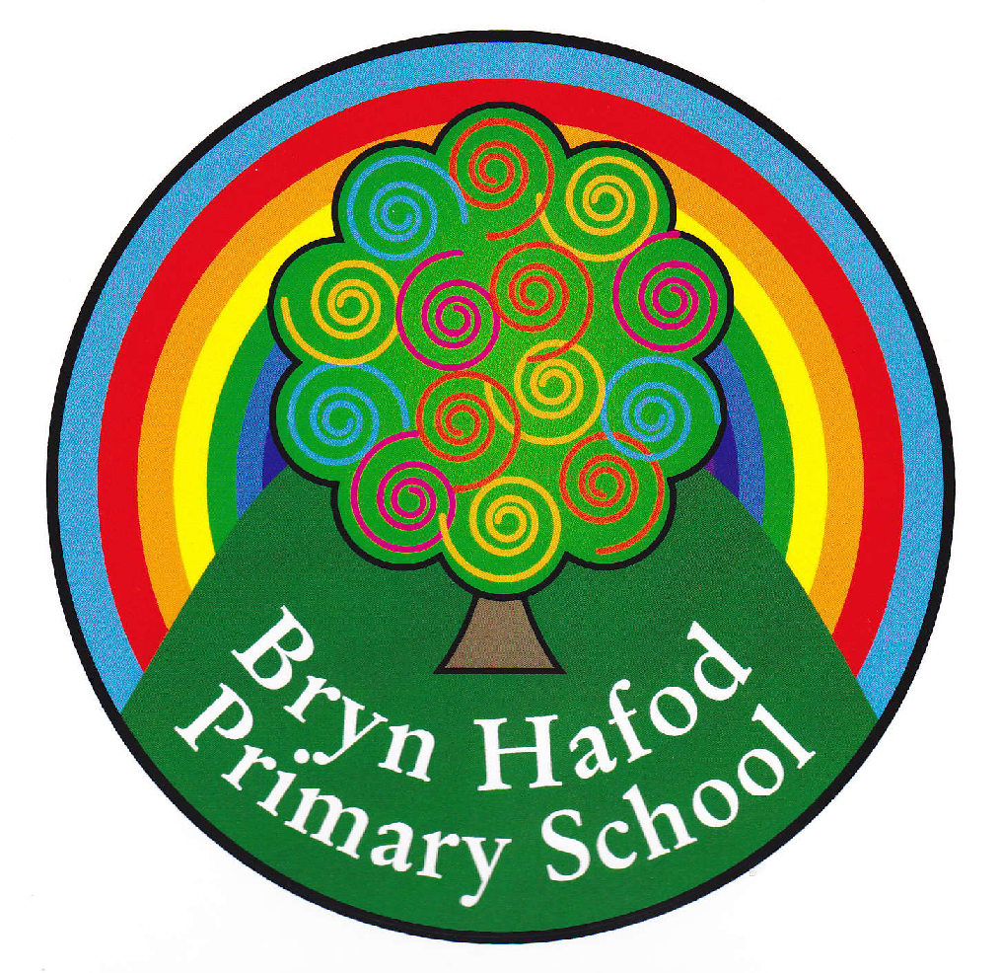
Choose any of the Home Learning tasks below. You can complete as many as you wish – you do not need to complete all of them! Please bring any work you complete into school so we can share this throughout our topic. Diolch yn fawr!
Home Learning.
Topic: Through the Keyhole!

Go for a walk in your local area and sketch a picture of your favourite place.  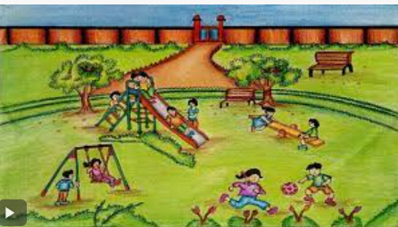 | Create a picture/model of your house. Tell me if it is detached, semi- detached, terraced, bungalow etc.  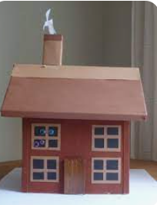 | We have been learning how to double and half numbers in maths.  These games on are great to help with this.  Enjoy playing them.  https://ictgames.com/mobilePage/archeryDoubles/index.html  https://www.topmarks.co.uk/maths-games/hit-the-button (click menu to change option to halves to 10)
Read your reading book with an adult for ten minutes at least three times a week.  Extension: Go to the library and choose a book to read. | We have been learning about clothes “dillad” in Welsh.  Can you draw a picture of yourself wearing your favourite clothes and label them in Welsh?  Word mat- at the bottom to support | 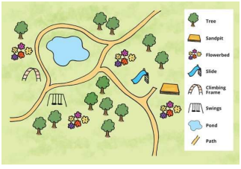  Draw a simple map of your local area with a key to support.
We have been writing acrostic poems in Literacy. You think of a word that starts with the same letter. i.e.  F- Fun  R- Running around  I- Independent  E- Enjoys singing  N- Nice  D- Dancing  Can you write an acrostic poem using a word of your choice? i.e. your name, a place, weather, colour etc. | Make a Christmas card for one of your friends and bring it to school.  Christmas is coming  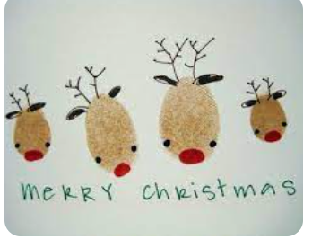 | We are learning about throwing and catching in PE.  Go outside and play catch with a grown-up, sibling or friend. How many can you catch before dropping it.  Share a picture/video on Seesaw for us to see.


