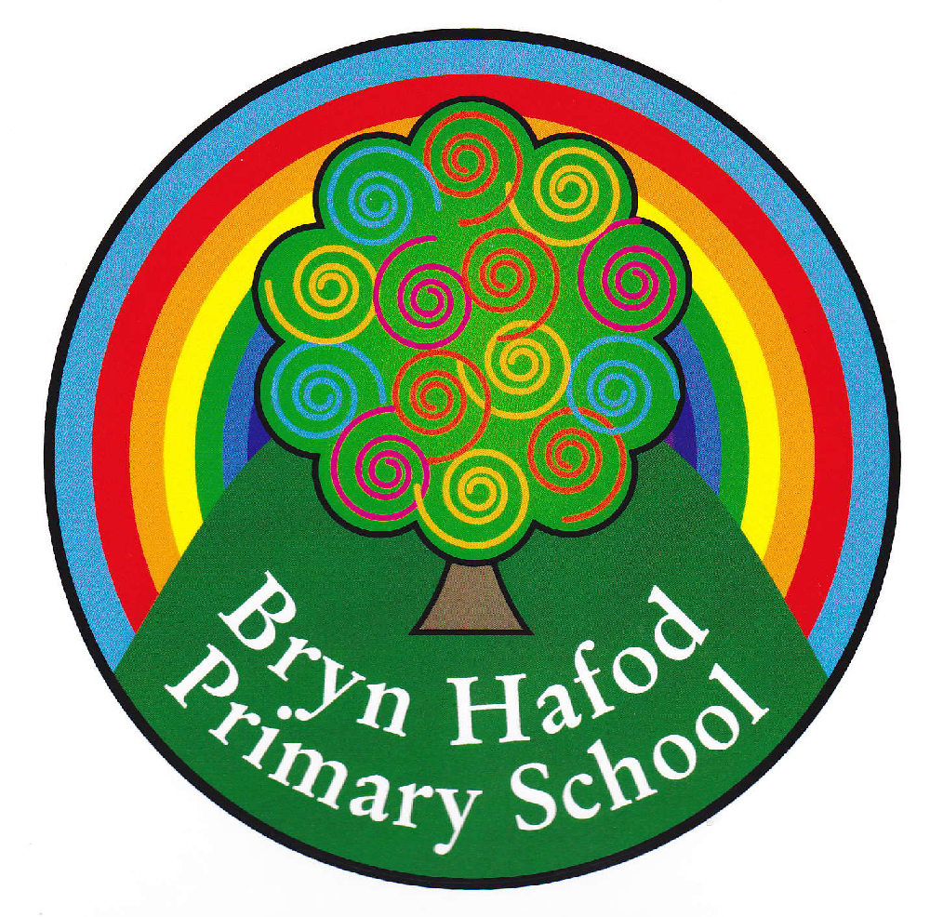
Home Learning. Topic : There is Only One Me !
Choose any of the Home Learning tasks below. You can complete as many as you wish – you do not need to complete all of them! Please bring any work you complete into school so we can share this throughout our topic. Diolch yn fawr!

Make a model or a collage of your favourite meal.  .  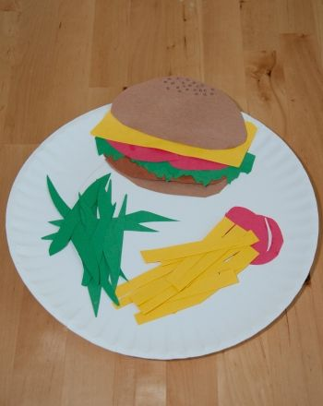 | We have been reading the book Supertato in class this term.  Watch the story and create a new front cover for Supertato  https://youtu.be/rze89HB9u8g?si=6whbUc2AWz2RnkDx  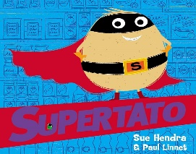 | We have been learning about ordering numbers.  These games on Top Marks are great to help with this.  Enjoy playing them.  https://www.topmarks.co.uk/ordering-and-sequencing/caterpillar-ordering  https://www.topmarks.co.uk/ordering-and-sequencing/coconut-ordering
Read your reading book with an adult for ten minutes at least three times a week.  Extension: Go to the library and choose a book to read.   | We have been learning about healthy eating.  Make a list of foods that are healthy.  We made fruit salad in school . Ask an adult if you can make fruit salad for your family. | Draw the characters from Supertato.  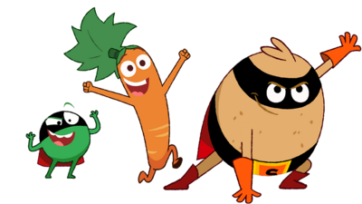
Draw a rainbow - write something kind you have done for somebody else in each section.  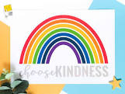 | We are learning about what makes a good friend.  Listen to this song and join in.  https://www.youtube.com/watch?v=bVCKj0T9-  gc | Exercise is important to keep our bodies healthy.  How many times can you do these things in one minute  Run on the spot  Touch your toes  Jump up and down  Sit down and stand up.

