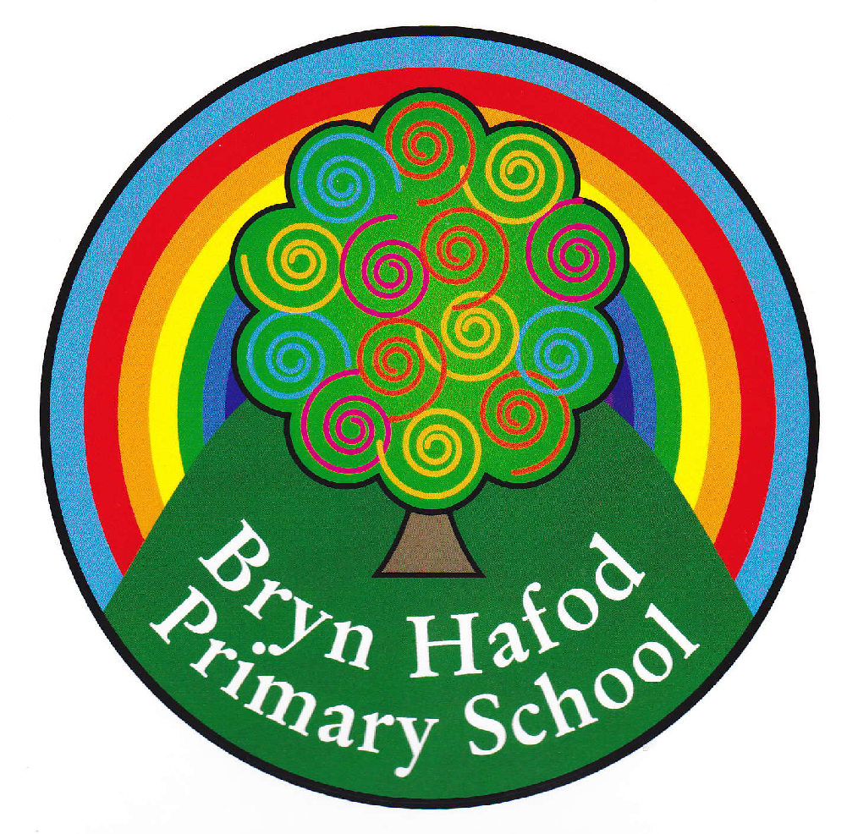
Choose any of the Home Learning tasks below. You can complete as many as you wish – you do not need to complete all of them! Please bring any work you complete into school so we can share this throughout our topic. Diolch yn fawr!
Home Learning.
Topic: Cymru a Fi!

We are learning about “Wales” in our topic this half term. We will be looking at Castles.  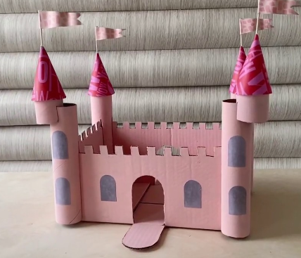  Can you link our numeracy skills with this and make a castle using 3D shapes around your home? Bring them in to share with us or upload a picture on Dojo or Seesaw.  Or- Visit Cardiff Castle with your family- take pictures and upload them so you can share your experience with the class. | Rhiannon Roberts aka Rhiannon Art will be inspiring us this half term. Can you pick your favourite place to go in Cardiff and make a picture in the style of Rhiannon?  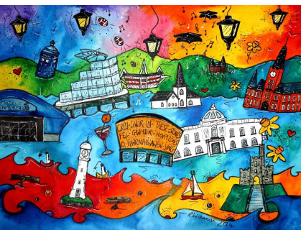 | We have been learning about 2D and 3D shapes in Numeracy. Test your skills and complete the games below.  https://www.topmarks.co.uk/early-years/shape-monsters  https://ictgames.com/mobilePage/shapeEscape/index.html
Read your reading book with an adult for ten minutes at least three times a week.  Extension: Go to the library and choose a book to read. | We have been learning the phrases “Beth wyt ti’n hoffi” in Welsh. It means “What do you like?”.  Can you draw a picture of your favourite toy and write “Dwi’n hoffi…” I like … and then a picture of a toy you do not like and write “Dwi’n ddim yn hoffi…” I do not like… | 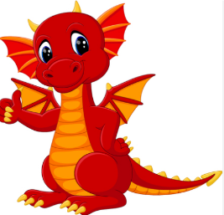  There is a Welsh Dragon on our flag. Can you write a short story about a Welsh dragon and draw pictures to support it. It only has to be 2-5 pages long. Maybe your dragon visited the cinema down Cardiff bay. What did he watch? What did he eat? Did he enjoy the movie? Where did he go next? Maybe a nice stroll down Cardiff bay. Remember to give your dragon a special name.
Complete some research on famous Welsh people. Can you create a fact file or record some facts about them to share with the class? You can upload them on Seesaw.  Some famous people;  Tom Jones  Gareth Bale  Roald Dahl | Design a new Welsh shirt for the six nations.  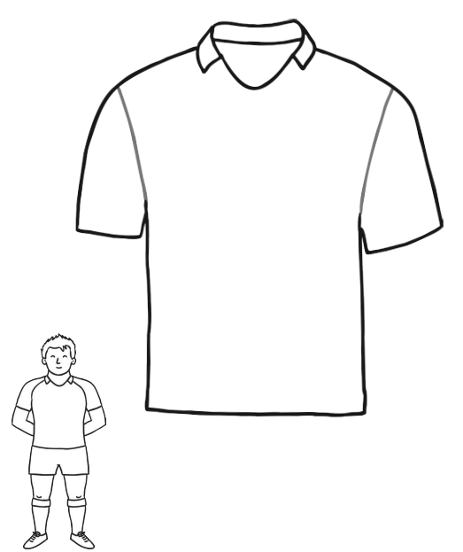 | Practise these key words at home.  

