Choose any of the Home Learning tasks below. You can complete as many as you wish – you do not need to complete all of them! Please bring any work you complete into school .
. Diolch yn fawr!
Home Learning.
Topic: Marvellous Materials

Expressive Arts  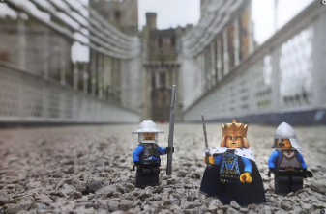  Welsh artist Andy Morris looks adding Lego to his photographs. Can you add your favourite toy to a special place and take a photograph for Seesaw? Talk about the materials you can see. | Health and Well-being  Can you add some extra exercise into your routine whether it’s going for a walk or challenging your siblings to some jumping jacks etc.  Post your success on Seesaw to share with your friends. | Humanities  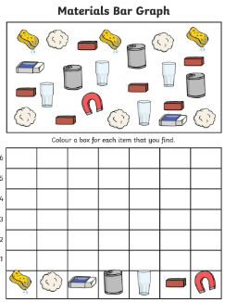  Can you complete a bar chart showing the materials in your home? What material is most popular?  (Up to 15 or 20)
Languages, Literacy and Communication  We looked at the poem “10 things in a wizard’s pocket”. Can you fill a plastic wallet or draw a picture of the things that you would find in your pocket i.e. your favourite toy, special books, something that represents you.  Can you write a list of the things you would find in your pocket and talk about your favourite thing in there? | Mathematics and Numeracy  We have been looking at days of the week in maths.  Can you write the days of the week in order and then draw a picture of something you did on that day? | Science and Technology  Can you create something out of different materials? Talk to your grownups about the materials used and what their properties are.

