Home Learning.
Topic: Pwy wyt ti? (Who are you?)

Choose any of the Home Learning tasks below. You can complete as many as you wish – you do not need to complete all of them! Please bring any work you complete into school or upload on Seesaw so we can share this throughout our topic. Diolch yn fawr!
Expressive Arts  Can you create a piece of artwork of you?  It could be a portrait using chalk, crayons, pencils, paint, collage etc. You might make a model using playdough or junk modelling (recycled materials) - you can be creative as you like.  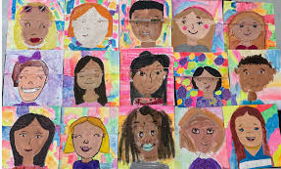 | Health and Well-being  Friends are so important to our well-being. What makes a good friend?  Can you write a list about what makes a good friend?  i.e.  - Being kind  - Makes me laugh | Humanities  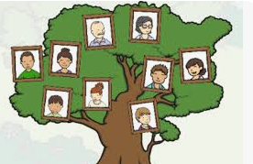  We are learning who you are as individuals. Family is a really important factor.  Can you design a family tree with help from your grownups?
Languages, Literacy and Communication  “ I can understand that people use different languages”  What languages do you speak? Can you make a poster about the language and put in some of your favourite key words- they could be greetings, animals, colours etc.  i.e. I am Joe and I speak English.  There are words like “Good morning” “dog” etc.  You may talk about more than one language. | Mathematics and Numeracy  We have been learning about ordering numbers.  These games on Top Marks are great to help with this.  Enjoy playing them.  https://www.topmarks.co.uk/ordering-and-sequencing/caterpillar-ordering  https://www.topmarks.co.uk/ordering-and-sequencing/coconut-ordering | Science and Technology  Can you create a human life cycle?  

