Year R/Y1_ Home Learning. Topic : There is only one me!
Choose any of the Home Learning tasks below. You can complete as many as you wish – you do not need to complete all of them! Please bring any work you complete into school so we can share this throughout our topic. Diolch yn fawr!
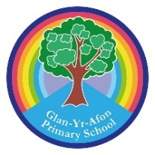
Write a list of three things you can do to help you to stay healthy.  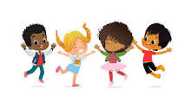 | Find leaves, stick, stones and any other natural materials and make them into a picture of yourself.  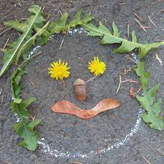 | Talk to someone at home about what you would like to do when you grow up. Try and find out a little bit more about it by talking to people who know about that role or looking in a book or on the Internet. Then, you can share what you have found out with the class.  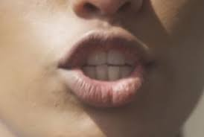
Share an All about me story you can find some on You Tube or why not visit the library and see what they have?  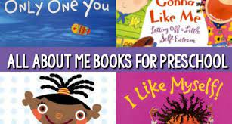 | When you get home, sit quietly and listen carefully to see what you can hear. Draw pictures of some of the things you could hear in your house or garden  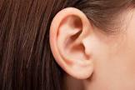 | Use some bits from your recycling boxes to make a picture of yourself  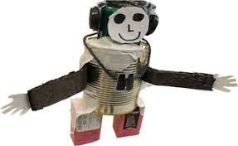
Ask a grown-up to help you to make a healthy fruit salad using the characters’ favourite fruits: strawberries, apples, bananas and grapes. Add your favourite fruit too.  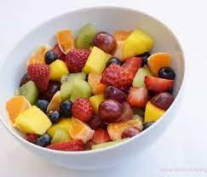 | Use some paint to make handprints of everyone’s hands in your family and then cut out the handprints. Can you put them in order of size from the smallest handprint to the largest handprint? If you haven’t got any paint, you could draw around hands instead!  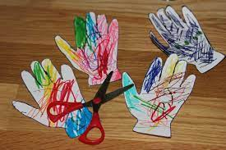 | Draw a picture that shows all of the people who are special to you.  

