Year R/Y1 Home Learning. Topic : Light and Dark
Choose any of the Home Learning tasks below. You can complete as many as you wish – you do not need to complete all of them! Please bring any work you complete into school so we can share this throughout our topic. Diolch yn fawr!
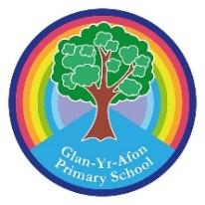

Design your own night sky. What can you see?  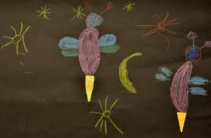 | Find leaves, stick, stones and any other natural materials and make them into a star shape.  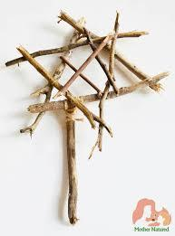 | Make a list of the different sources of light that you can find inside and outside your house.  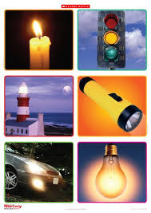
Share a moon or a star story there are lots on you tube or you could look for one in the library. Take a photo of you and your book or copy down the name and we will share it in class.  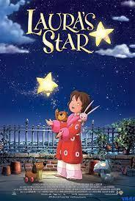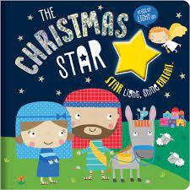 | Watch Light and Dark on BBC Bitesize.  https://www.bbc.co.uk/bitesize/articles/zxyn3qt   | Use some bits from your recycling boxes to make a rocket.  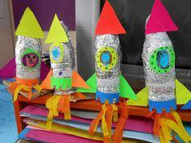
Build your own darkroom using blankets and a torch. Fill your darkroom with shiny and bright coloured things, What do they look like using a torch?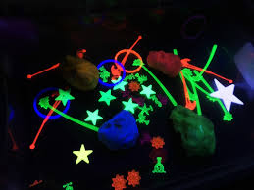 | Set up a toy on some white paper. Can you draw the shadow?  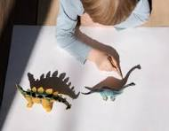 | Make a name rocket. You need one of the letters from your name on each coloured piece.  

