Dear Parents/ Guardians,
HWB is a digital "learning platform" designed to allow all pupils and teachers in Wales greater access to online trusted resources.
To log on to HWB simply go to https://hwb.gov.wales/ and enter your child’s HWB username and password.
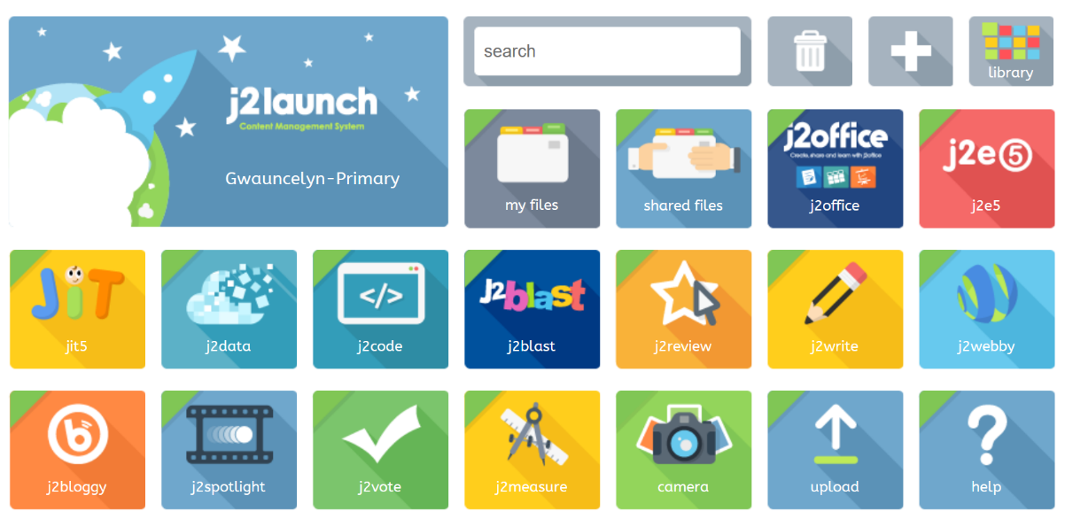
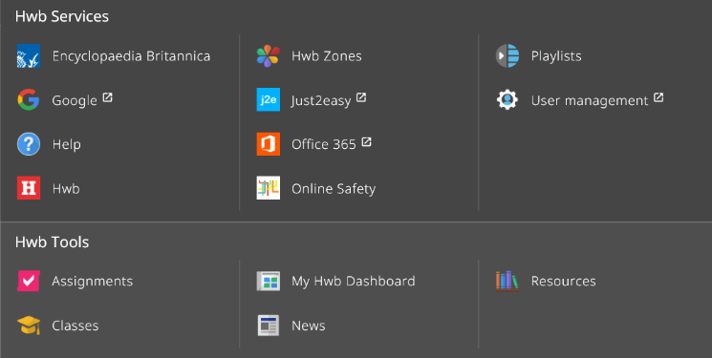
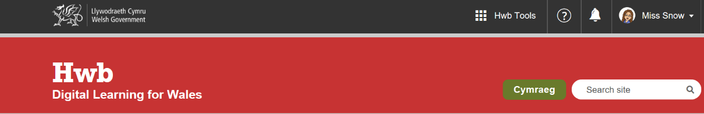
Once signed in, your child will have access to a range of resources which can be filtered to your child’s age and interests. Encyclopaedia Britannica is a particularly useful search engine. There is also a link to access information about keeping safe online.
Click on HWB tools at the top of the page to access J2 Launch. Here you will find all sorts of resources to access at home (see below) Any work saved will appear in “My Files” Your child also has free access to Office 365 online (which includes Outlook e-mail and online office apps including Word, Excel and PowerPoint)
Please keep your username and password safe! Your child’s username will stay with them throughout school.

