Home Learning.
Topic: Sparkle and Shine.

Choose any of the Home Learning tasks below. You can complete as many as you wish – you do not need to complete all of them! Please bring any work you complete into school so we can share this throughout our topic. Diolch yn fawr!
Expressive Arts  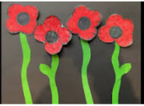  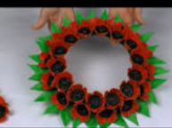  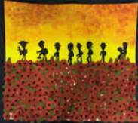  Can you create a piece of art expressing “Remembrance Day”?  This could be a painting, collage, junk modelling, clay, drawing etc. | Health and Well-being  Practice our Christmas concert songs at home.   | Humanities  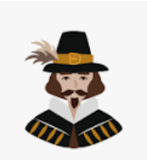  Can you complete a biography on Guy Fawkes? Remember to include:  - Pictures  - His name/DOB  - Where he was born  - What he did etc.  You can be as creative as you like with this. You can complete on paper/card or complete on a computer or laptop.
Languages, Literacy and Communication    Can you make a Christmas list and bring it in to share with the class?  If you don’t celebrate Christmas, it can be a list of your choice.  Remember how to write a list. | Mathematics and Numeracy  We have been learning about 2D and 3D shapes. Can you go on a shape hunt at home and make a list of all of the shapes you see? You could even upload pictures on Seesaw.  Challenge: Make a tally chart of all the shapes you find. | Science and Technology  .We are going to be learning about light. Can you find things in your house that provide us with light. Make a list or get creative and draw some pictures.

