Home Learning.
Topic: Out of this World

Choose any of the Home Learning tasks below. You can complete as many as you wish – you do not need to complete all of them! Please bring any work you complete into school so we can share this throughout our topic. Diolch yn fawr!
Expressive Arts  Our new topic is Out of this World.  Can you draw , paint or make a model of something to do with space.  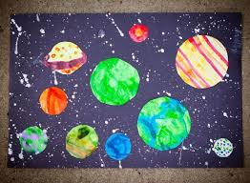 | Health and Well-being  We have just celebrated New Year . It is now 2026.  Talk to an adult about all the things you are looking forward to this year or the things you feel grateful for.  Draw pictures or write words to make a list.   | Humanities  Can you complete a biography about Neil Armstrong. He was the first man on the moon  Remember to include:  - Pictures  - His name/DOB  - Where he was born  - What he did etc.  You can be as creative as you like with this. You can complete on paper/card or complete on a computer or laptop.
Languages, Literacy and Communication  You are going on a mission to space .  What would you pack in your suitcase?  Draw and label items in your suitcase.  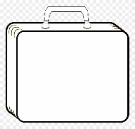 | Mathematics and Numeracy  We are going to be learning about money.  Draw and label all the coins you know,  Play the toy shop money game on Top Marks  https://www.topmarks.co.uk/money/toy-shop-money | Science and Technology  .We are going to be learning about the planets.  Draw and name as many planets as you can.  

