Home Learning.
Topic: Celtic Cymru

Choose any of the Home Learning tasks below. You can complete as many as you wish – you do not need to complete all of them! Please bring any work you complete into school so we can share this throughout our topic. Diolch yn fawr!
Expressive Arts  Design a Celtic shiels. You can use any materials you want.  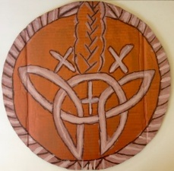  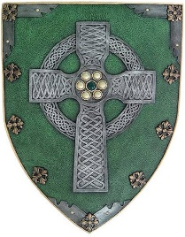 | Health and Well-being  The Celts lived close to nature,  Spend ten minutes outside. Think about  3 things you can ear  2 things you can see  1 thing you can touch safely  Then draw or write about your favourite moment. | Humanities  Find three facts about the Celts.  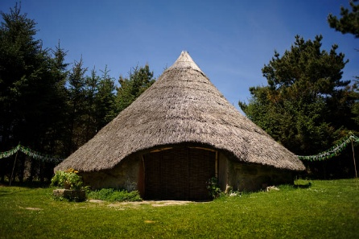
Languages, Literacy and Communication  Invent a Celtic child and write a few sentences about them  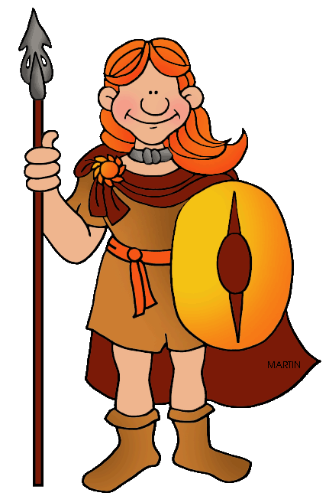  What do they wear?  Where do they live?  What is their name?  Draw a picture. | Mathematics and Numeracy  Create a simple repeating pattern using shapes.  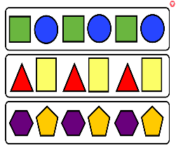 | Science and Technology  The Celts were the first people to use iron. Iron is a type of metal.  Make a list of all the things made of metal in your house.  What other materials can you find?

